NAME: Emmanuel Ikpesu

PROJECT: Exploring Weather Trends

**STEPS**

The project was carried out following the below steps:

1. Previewed each table on the data base using SQL, made a rough table of the columns and observes the tables relationship

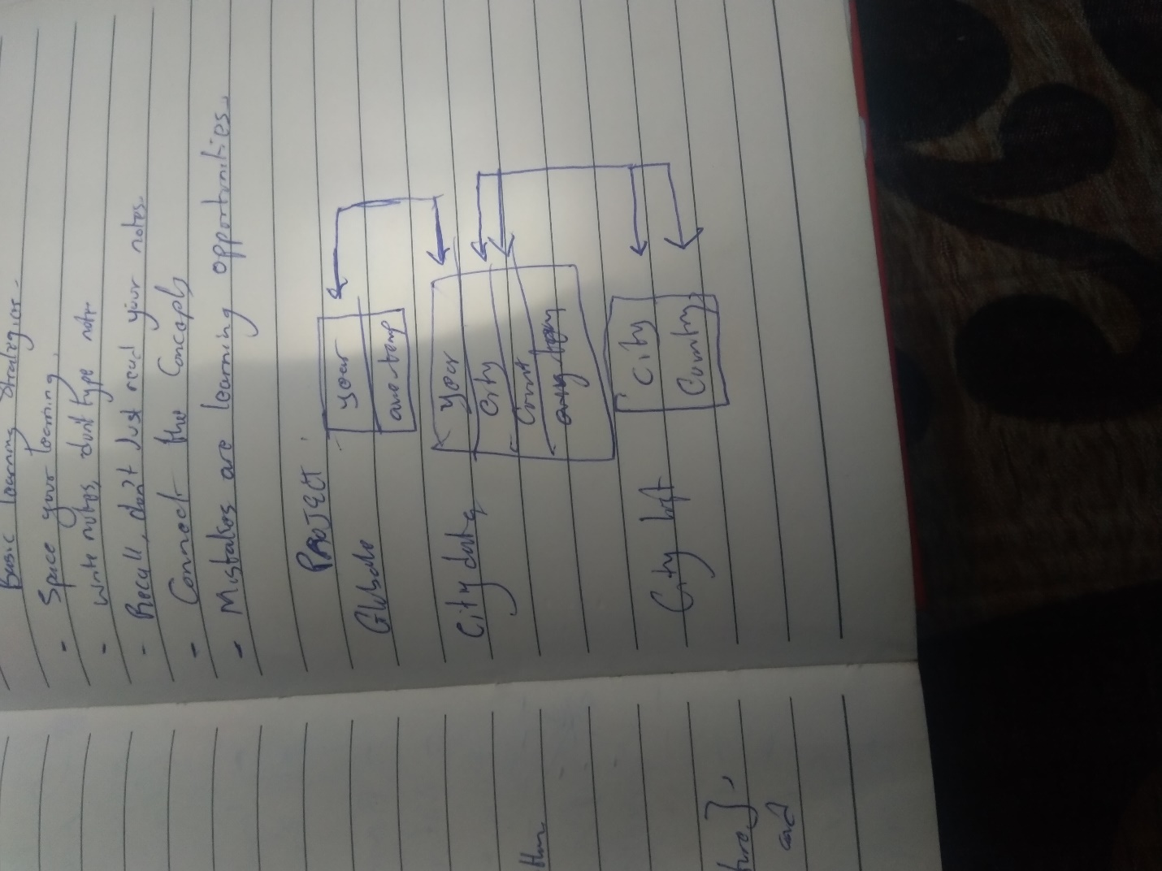

1. Extracted Global avg. temp data from data base

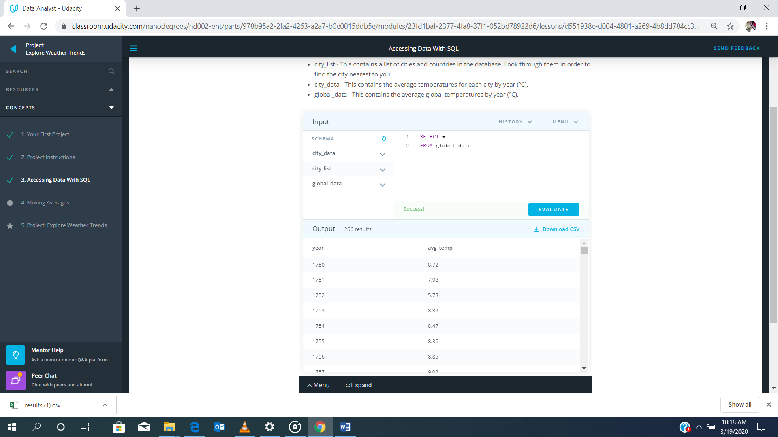

1. Opened the city_list table and filtered the data to know the list of cities in my country (Nigeria) which are available on the data base and choose Lagos because it was the one closest to me. 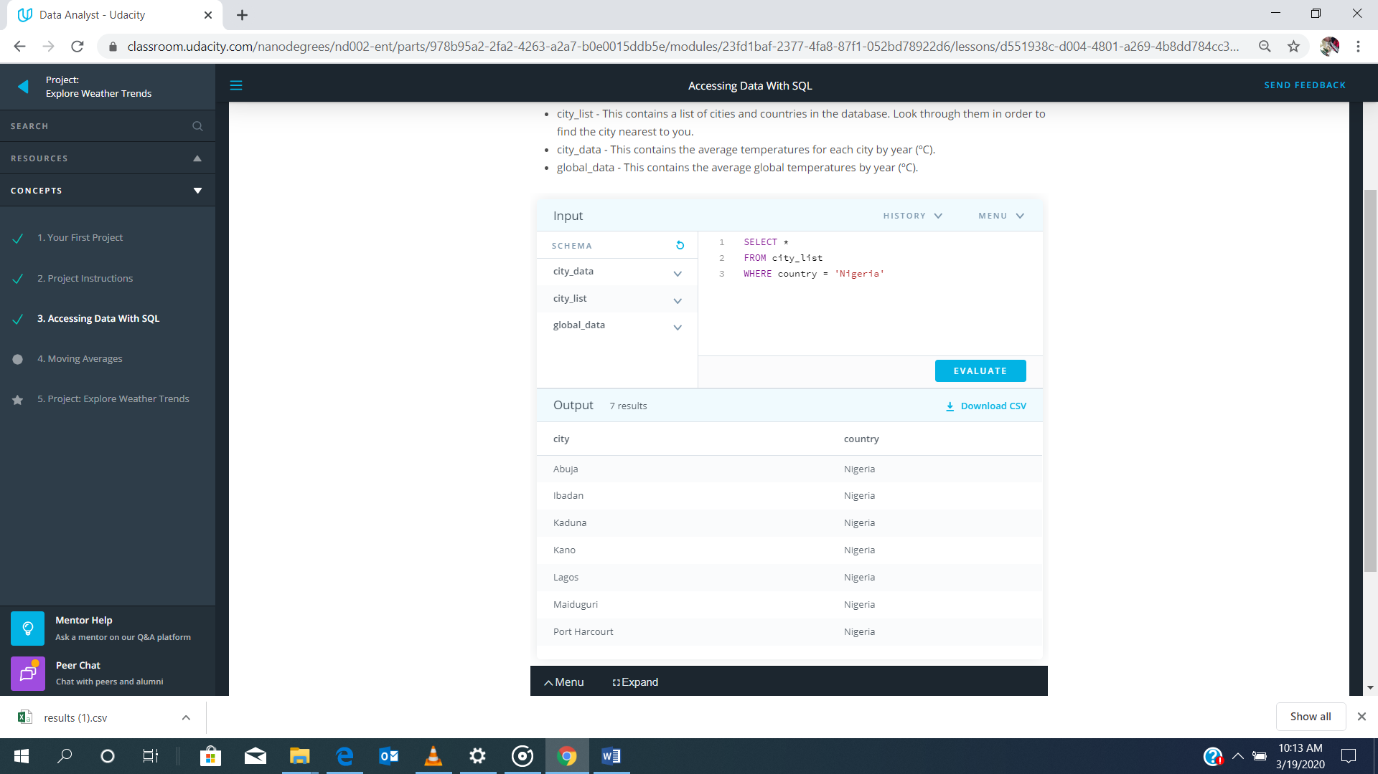
2. Combined city_data and city_list (Optional), filtered by country being Nigeria and city being Lagos and extracted data with only year and avg_tempt (as city_avg_temp).

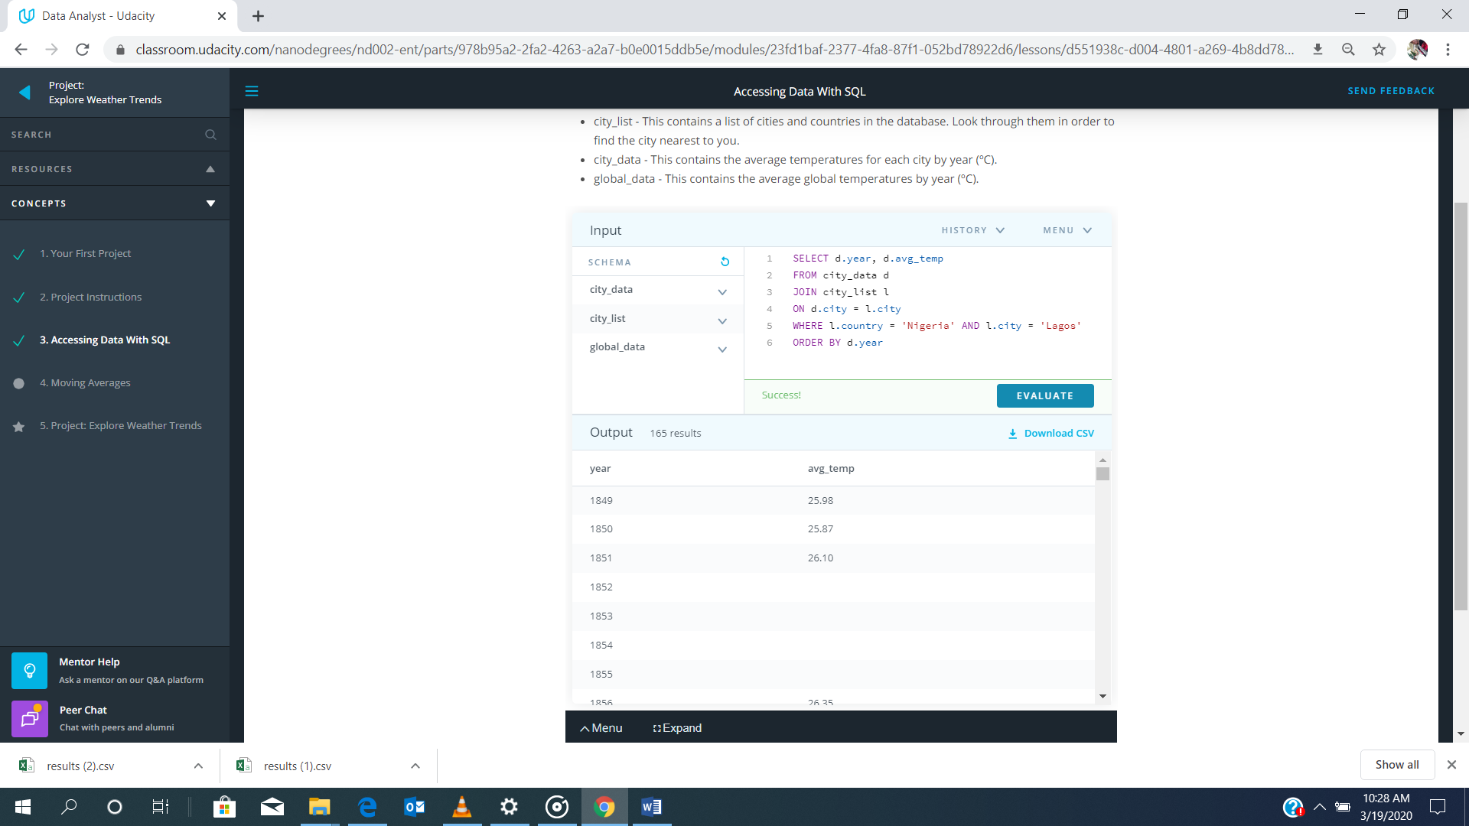

1. Combined the global_data table with the table in step 4 and extracted it.

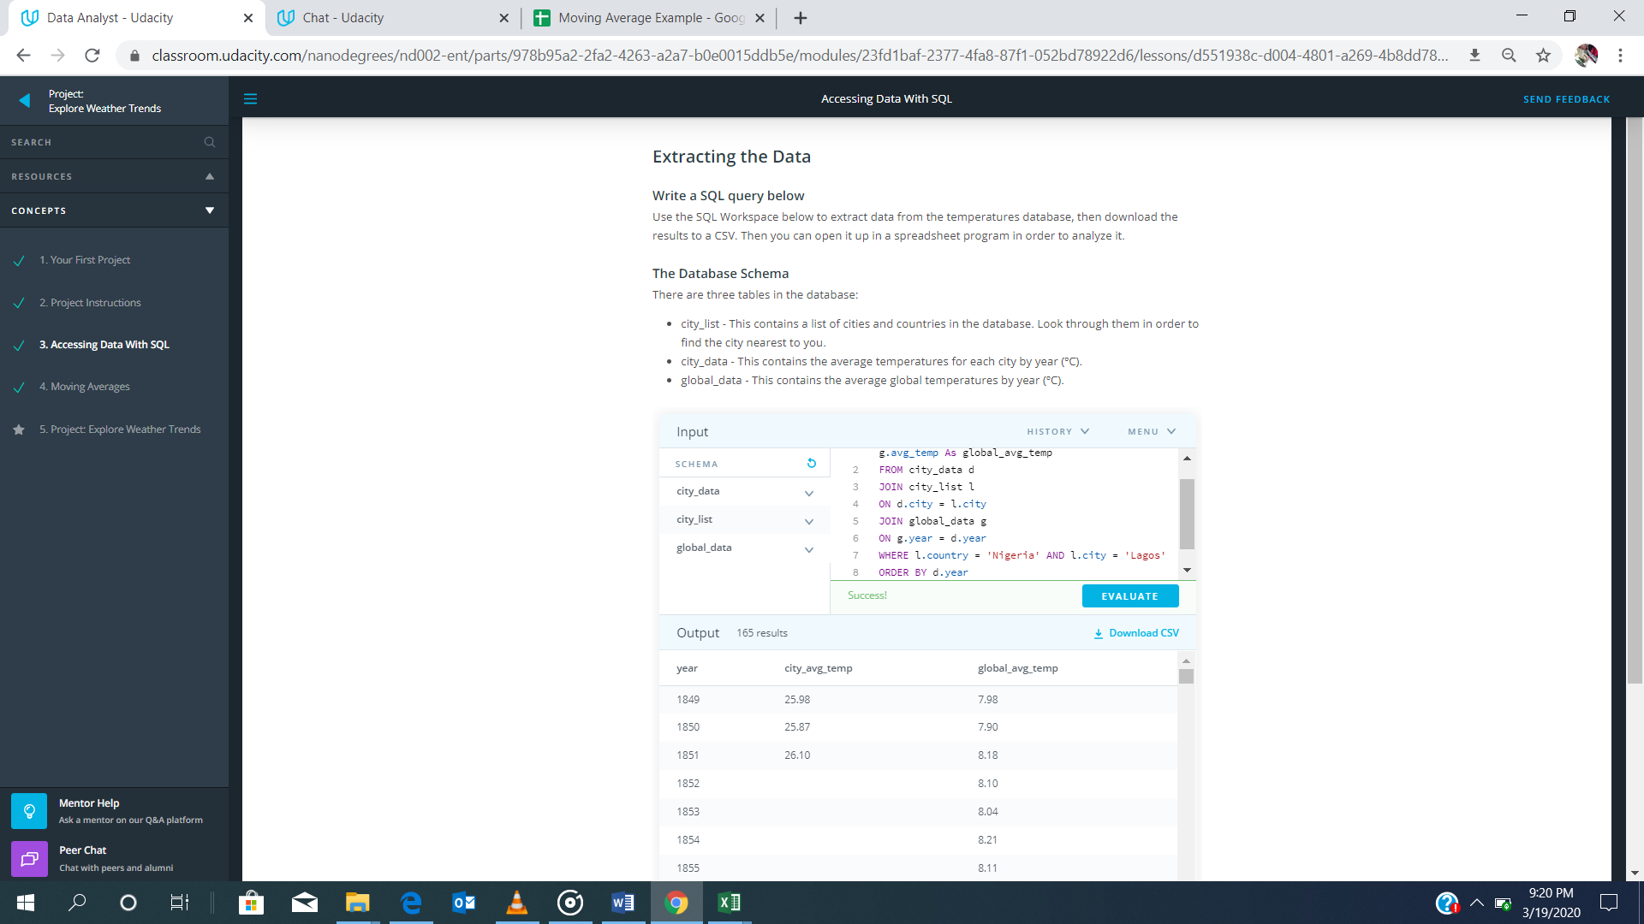

1. Using excel, a line chart was created to visualize the different extracted data. Due to the fluctuation of this data, different moving average where created and the 20 years moving average was server to be best to conduct the analysis. v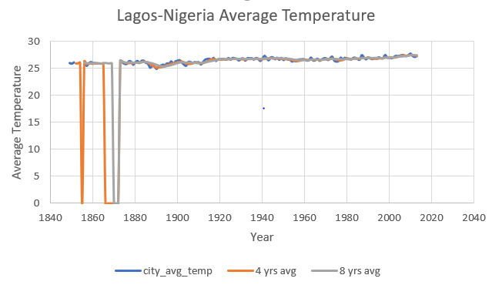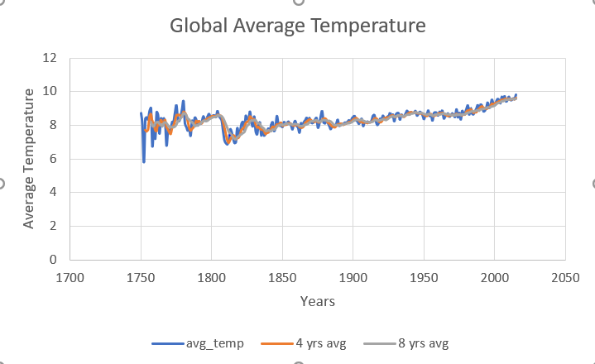

Yearly average, 4- and 8-years moving average

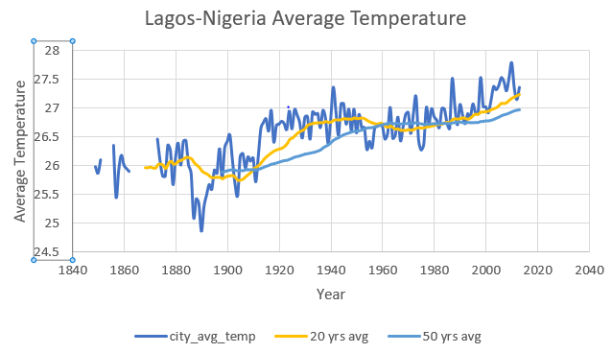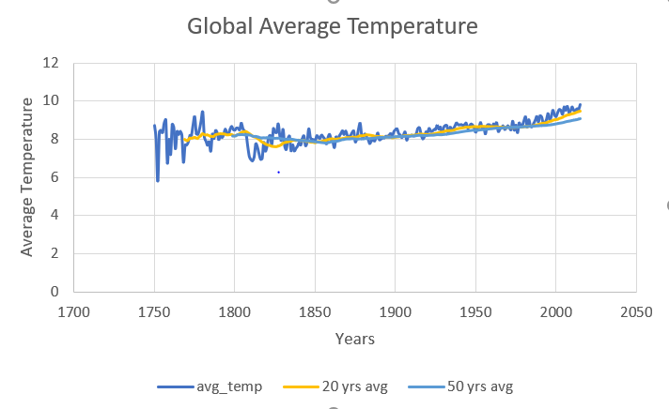

Yearly average, 20- and 50-years moving average

It was observed that 20-years moving average had a smoother trend with less unaccounted years.

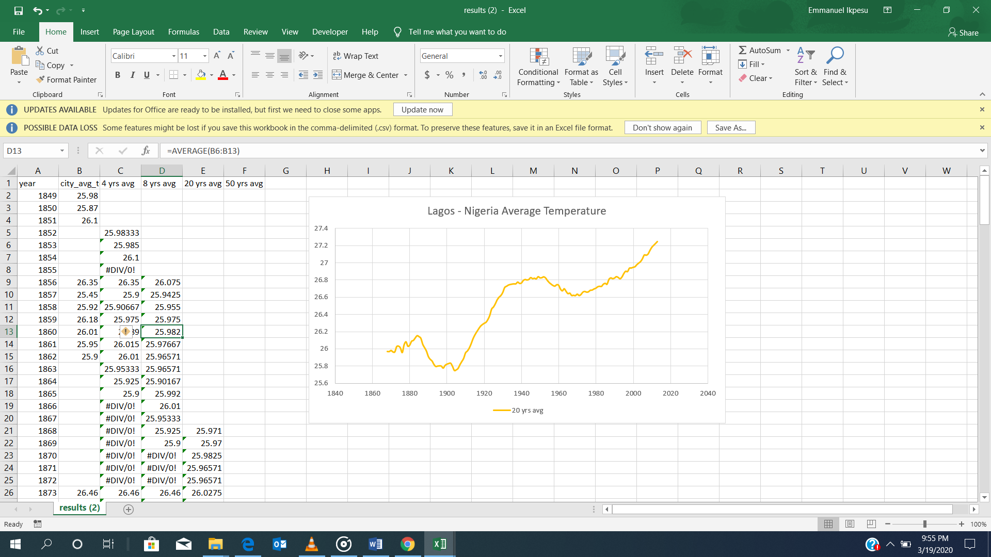

Table sample

1. A line chart was then created using the table extracted in step 5 and 20-years moving average was used.

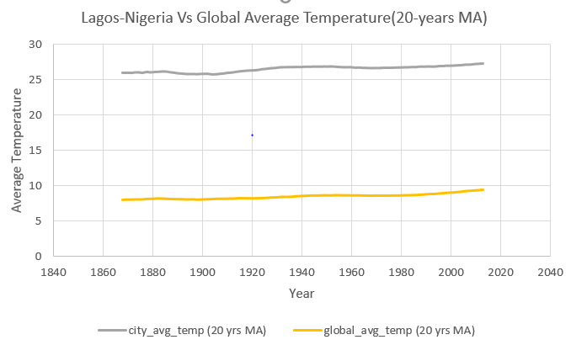

**OBSERVATIONS**

1. My city (Lagos- Nigeria) is hotter on average compared to the global average
2. The difference in both average temperatures has been approximately consistent (18)
3. The change in temperature over time in my city (Lagos-Nigeria) is similar to the global average change
4. The overall trend is an upward moving curve, which implies that the world is getting hotter and this trend has been consistent over the last 100-years
5. My city (Lagos- Nigeria) average temperature is approximately equal to 3 times the global average